SW Engineering CSC648/848 Summer 2018

# Hat Box Photos

## Team 5 Amelia Rawlings ([Amelia.Rawlings@gmail.com](mailto:Amelia.Rawlings@gmail.com))

## Front-End Arnold Jiadong Yu Dalu Li Betty Reaney

## Back-End Keawa Rozet U Keong Cheong (Ray) Albert Du

# Milestone 2

|  |  |  |
| --- | --- | --- |
| Revision Table | | |
| 7/6/2018 | 1.0 | Initial document |
|  |  |  |

**Data Definitions**

**Account**: User account with username and password as credentials.

**Admin**: Registered user with the privilege to approve or reject uploaded images after review

* Admins shall log in to their account on hatboxphotos.com before reviewing images
* Admins shall review the content and description of all uploaded images before they go live on hatboxphotos.com
* Admins shall notify users in a message about why an uploaded image was not approved to go live
* Admins possess non-admin user privileges in addition to their admin privileges

**Image**: Full resolution image.

* **Downloads:** The number of times an image is downloaded from hatboxphotos.com
* **File size:** Size of the image file
  + File size shall be limited to
* **Image description**: Text description of an image.
  + Image descriptions shall be limited to a certain length
  + Image descriptions shall be optional
* **Image height**: Height of an image measured in pixels
* **Image file format:** Format of an image file
  + File formats shall be limited to
* **Image name**: Name of an uploaded image on hatboxphotos.com
* **Image width:** Width of an image measured in pixels
* **Resolution:** The level of detail in an image
  + Image resolution shall be measured by image width and image height
  + Full image resolution shall be
  + Medium image resolution shall be
  + Thumbnail resolution shall be
* **Tag**: Category of an image (i.e. clothing, furniture, landmark, outdoor).
  + Image tags shall facilitate image search performed by users.
  + Images shall only have one tag
* **Thumbnail:** Preview of an image
  + Thumbnails shall be displayed in search results
  + Thumbnails shall be displayed in place of full resolution images to users who are not logged in to their account

**Data Definitions (cont.)**

**Image**: (cont.)

* **Upload date**: Date an image was uploaded to hatboxphotos.com
* **Uploaded by**: Name of the registered user who uploaded an image to hatboxphotos.com
* **Views**: The number of views an image receives from all users on hatboxphotos.com

**Image database**: Database containing information about all images on hatboxphotos.com, such as image name, description, tags, thumbnail, and upload date.

**Non-admin user**: Registered user with the basic privileges of uploading and downloading images (i.e. students, photographers, etc.)

**Registered user**: User with an account on hatboxphotos.com

* Registered users shall be separated into admins and non-admin users
* Registered users shall log in to their account before uploading or downloading images
* Users shall provide their age, username, and password during the registration process
* Users shall have the option to provide their bio, occupation, and student status during the registration process

**Unregistered user**: User without an account on hatboxphotos.com

* Unregistered users shall only be able to view image thumbnails in place of full resolution images
* Unregistered users shall not be able to upload or download images

**User**: Anyone who visits hatboxphotos.com

* Users shall be separated into registered users and unregistered users
* Users shall be able to search for images
* Users shall be able to view image thumbnails

**Functional Requirements**

**Priority 1:**

1.1 Unregistered users shall be able to view photos on the home page

1.2 Unregistered users shall be able to sign up with an email and password  
1.4 Unregistered users shall be able to view thumbnail image in place of full resolution images  
1.5 Unregistered users shall be able to click on a thumbnail image and view it in medium resolution as well as its description  
1.6 Unregistered users shall be prompted to sign up/in before downloading/uploading a photo  
2.1 Registered users shall have the same functionality as an unregistered user  
2.2 Registered users shall be able to login with their email and password  
2.3 Registered users shall be able to download an image in thumbnail, medium resolution, or high resolution  
2.4 Registered users shall be able to upload an image  
2.6 Registered users shall be able to view their profile  
3.1 Admin users shall have the same functionality as a registered user  
3.2 Admin users shall review the content and description of all uploaded images  
3.3 Admin users shall click approve if photo reviewed is acceptable  
3.4 Admin users shall click decline if photo reviewed is not acceptable  
3.6 Admin users shall be able to remove any previously approved photo  
4.5 Photos shall be viewed on the home page  
4.7 Photos shall be viewed in thumbnail and medium resolution for unregistered users.

**Priority 2:**

1.3 Unregistered users shall be able to use the search bar to search for specific photos  
2.5 Registered users shall be updated if their uploaded image was approved/declined  
3.5 Admin users shall have the ability to edit the template approve/decline email that is sent to the registered user  
4.1 Photos shall have the ability to be described by tags  
4.2 Photos shall have a description  
4.3 Photos shall show the date it was posted  
4.4 Photos shall show the Registered user who posted it  
4.6 Photos shall be viewed determined by search results  
5.1 Search bar shall have fuzzy search functionality

**Priority 3:**

None at this time.

**UI MOCKUPS AND STORYBOARDS**

**Use Case 1:**  Mary is a **college student**. She received a writing assignment about the city of San Francisco and had to use three landmark photos in her paper. When she gets home, she opens the home page of hatboxphotos. She searches the landmarks of San Francisco. Once she decides which landmark photos to use, she selects it, and is then prompted to register for a new account or log-in before she can download them to her local computer. Then she proceeds to log out.

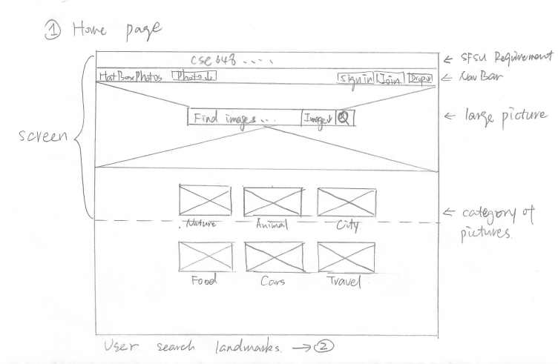

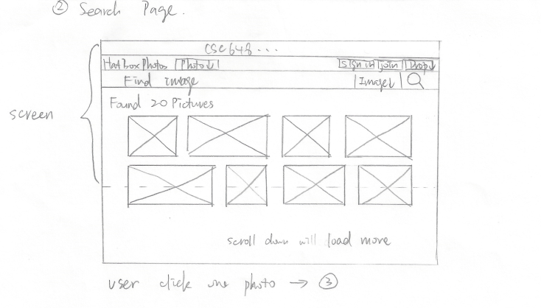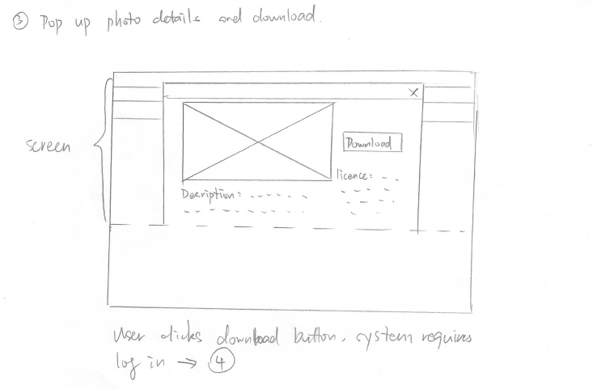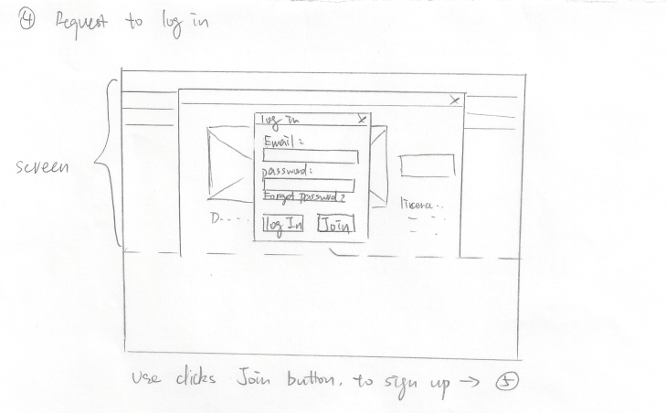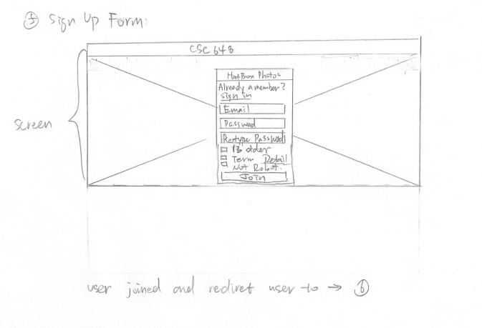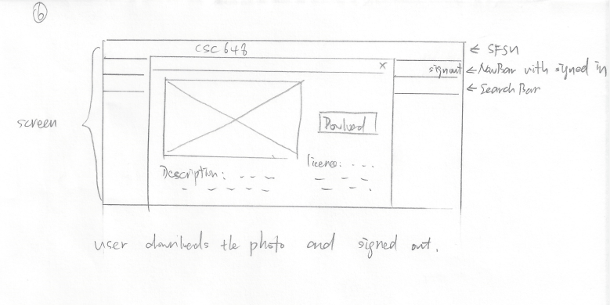

**Use Case 2:**  Henry is a **photographer**. He had taken a trip to San Francisco and took lots of photos about the city. When he gets back home, he opens the home page of hatboxphotos. He logs-in, chooses the photos that he wants to upload, writes a description about each photo, and upload them one by one for approval. Then he proceeds to log out.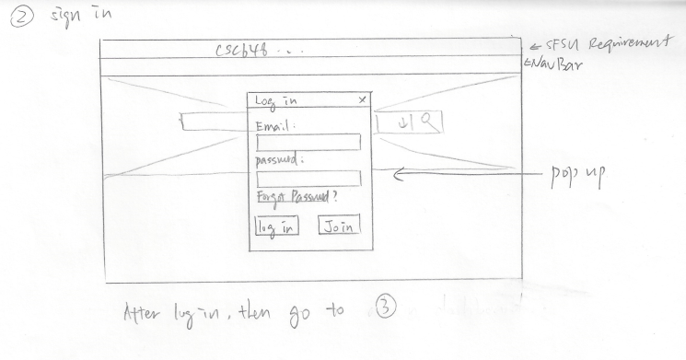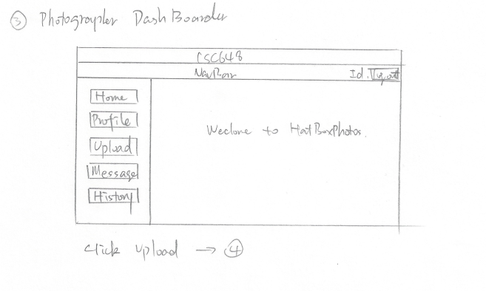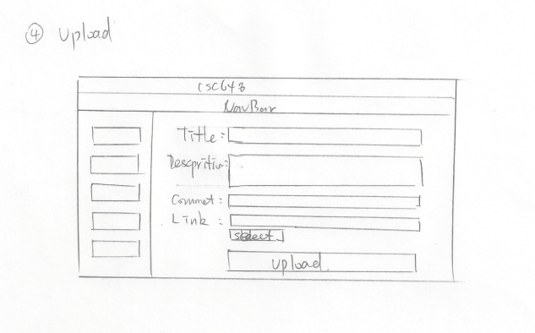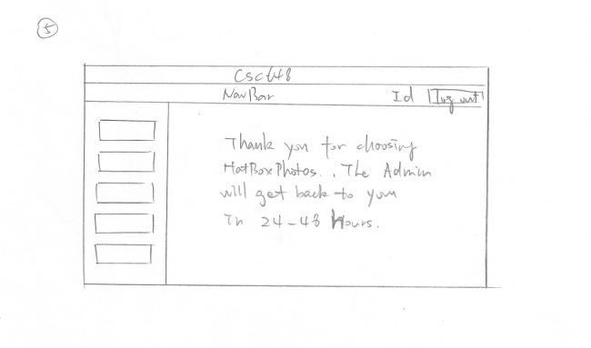

**Use Case 3:**  Jennifer is an **admin**. When she starts to work, she opens the home page of hatboxphotos and logs into her account. Then she navigates to photo approval section. She reviews each photo and its description, then decides to approve or decline the request. She views the template email for approving/declining a photo and decides to add an additional section to further explain her decision. She finishes typing and submits her choice, sending an email to the picture’s uploader. 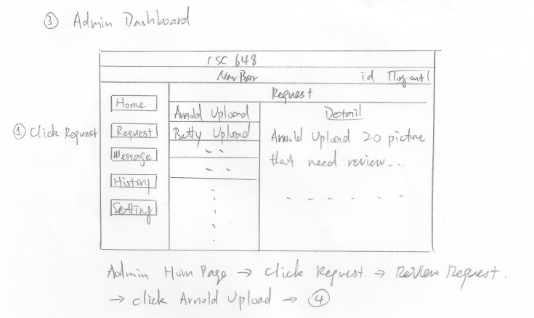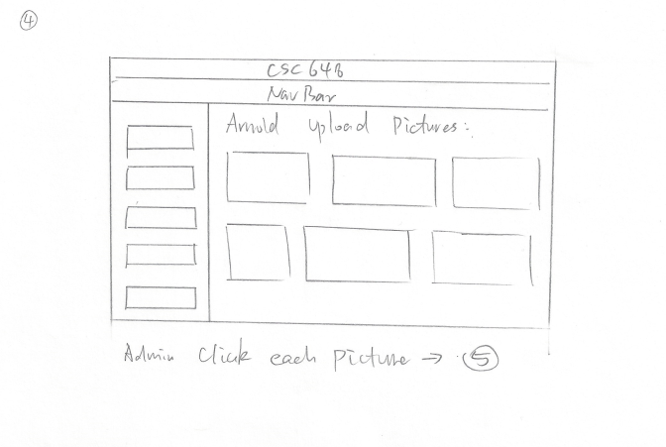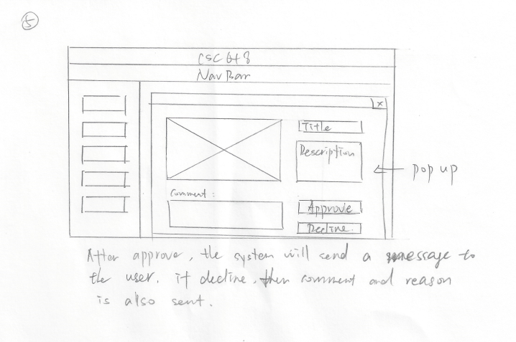

**High level Architecture, Database Organization**

**DB organization:**

* *Images Collection*
  + Image Document
    - ObjectID: image_id (auto generated by MongoDB)
    - GridFS: image_original
    - Base64: image_medium
    - Base64: image_thumbnail
    - String: image_file_name
    - String: image_file_format
    - String: category
    - String: uploaded_by
    - Date: upload_date
    - Int: file_size
    - Int: image_height
    - Int: image_width
    - Int: views
    - Int: downloads
    - String: image_description
* *Registered Users Collection*
  + Account Document
    - Login Credentials Schema
      * ObjectID: _id (auto generated by MongoDB)
      * String: email
      * String: username
      * String: password
  + Permissions Document
    - Const: permissions
      * ADMIN
      * NON_ADMIN

**Media storage:**

* Files
  + Base64 format
* GridFS
  + used for storing files above 16mb

**Search/filter architecture and implementation:**

* Fuzzy search
  + Partial search using regex

# High Level UML Diagrams

**Server UML:**

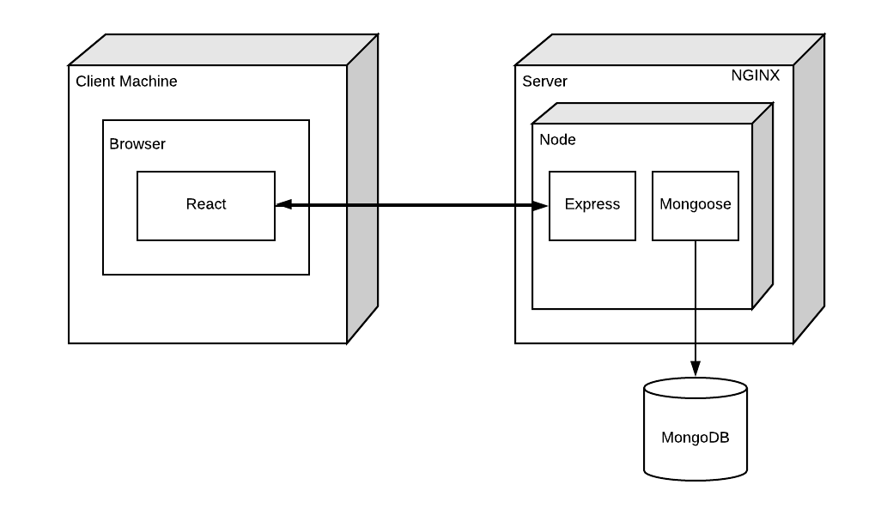

**Database UML:**

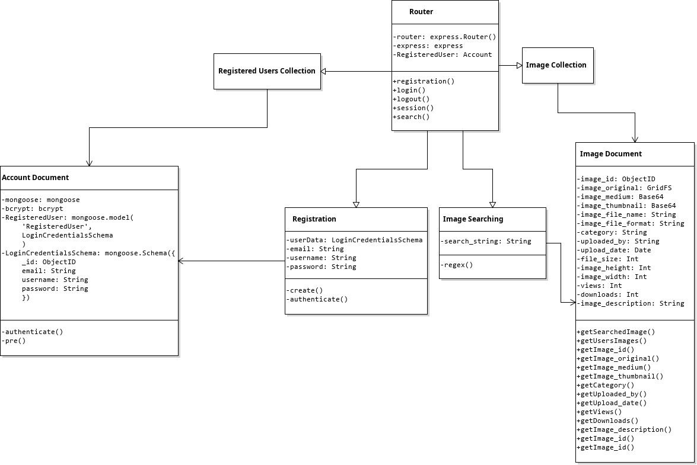

**Key Risks**

**Skills:**  Medium risk. We are still learning many of the tools that we are using. However, we are learning fast and sharing our knowledge, thus mediating this risk.

**Schedule:**  No risk at this time. All milestones thus far have been met on-time without the panic of the 11th hour.

**Technical:**  No risk at this time. All previous technical issues have been resolved and measures put in place to prevent further problems.

**Teamwork:**  No risk at this time. Teamwork is productive.

**Legal:**  No foreseen risks at this time.